**TUGAS 01**

**APLIKASI FLUTTER**



Praktikum Pemrograman Berbasis Web - A

Nama :

Adelia Nurlina Putri 4521210059

**PROGRAM STUDI S1 TEKNIK INFORMATIKA**

**FAKULTAS TEKNIK**

**UNIVERSITAS PANCASILA**

**JAKARTA**

**2024**

1. **Instalasi Flutter SDK**
2. Akses web <https://docs.flutter.dev/get-started/install>
3. Pilih OS yang digunakan untuk penggunaan Flutter : macOS

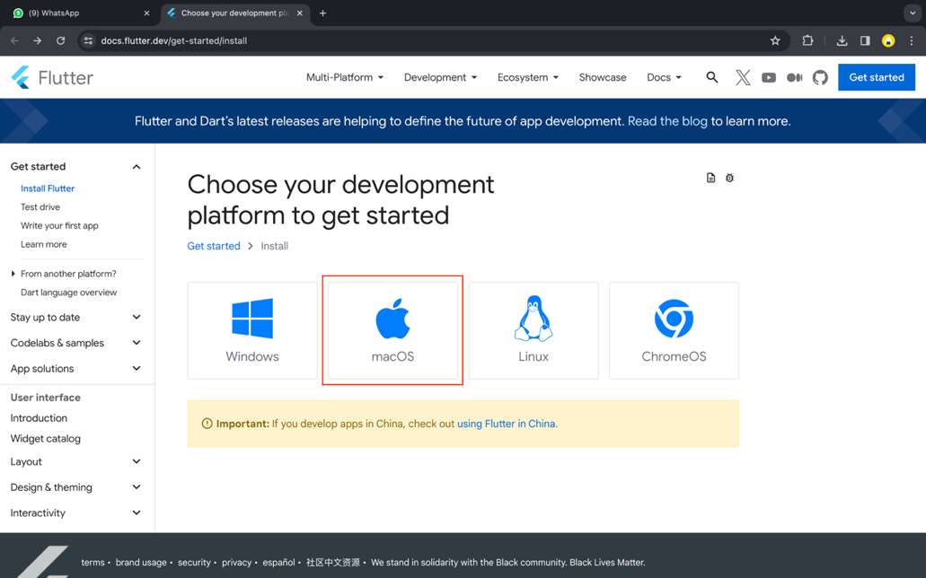

1. Pilih tipe App : Android

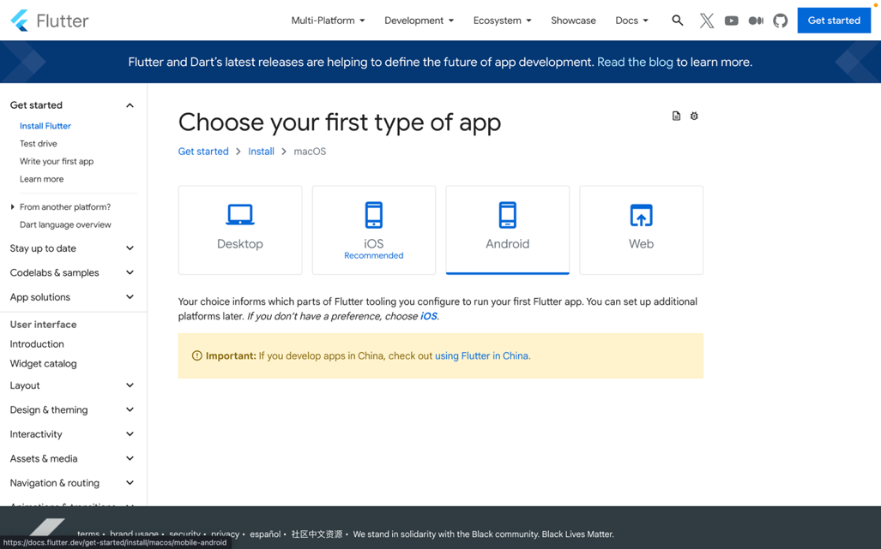

1. Cek default shell (Flutter support MacOS Catalina default shell menggunakan zsh)

|  |
| --- |
| dscl . -read ~/ UserShell |

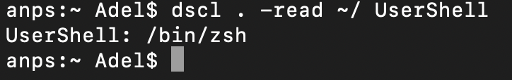

1. Beberapa komponen Flutter memerlukan proses Rosetta 2 di Mac Apple Silicon. Untuk menjalankan semua komponen Flutter di Apple Sillicon, maka perlu instal Rosetta 2.

|  |
| --- |
| sudo softwareupdate --install-rosetta --agree-to-license |

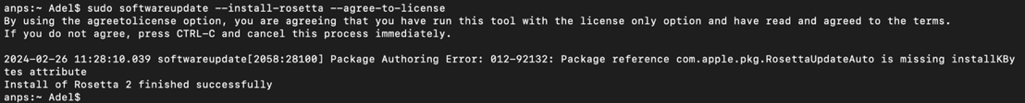

1. Download & Install Visual Studio Code (Installed)
2. Install Flutter Extension

|  |
| --- |
| Buka VSCode -> Marketplace -> Ketik Flutter -> Install |

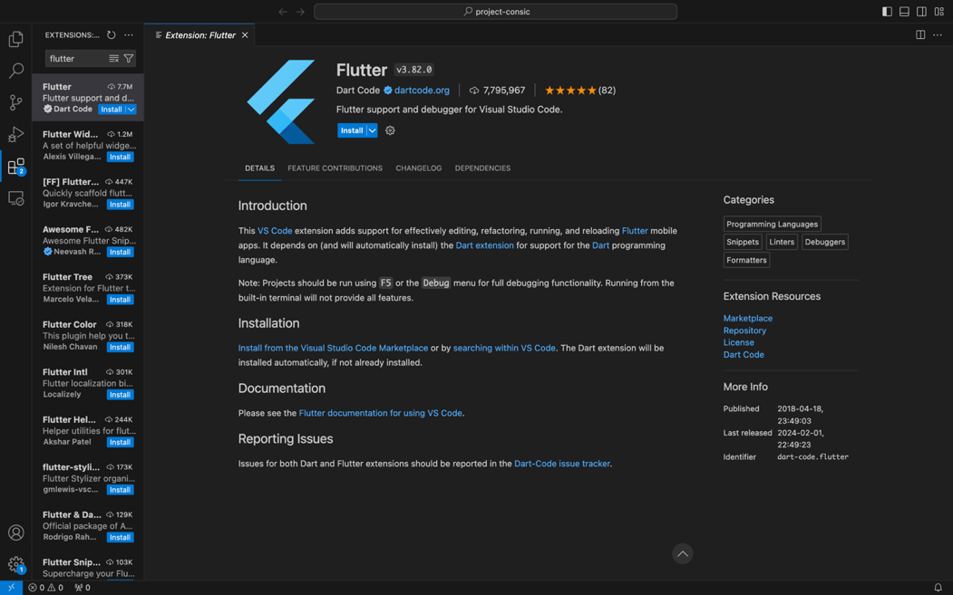

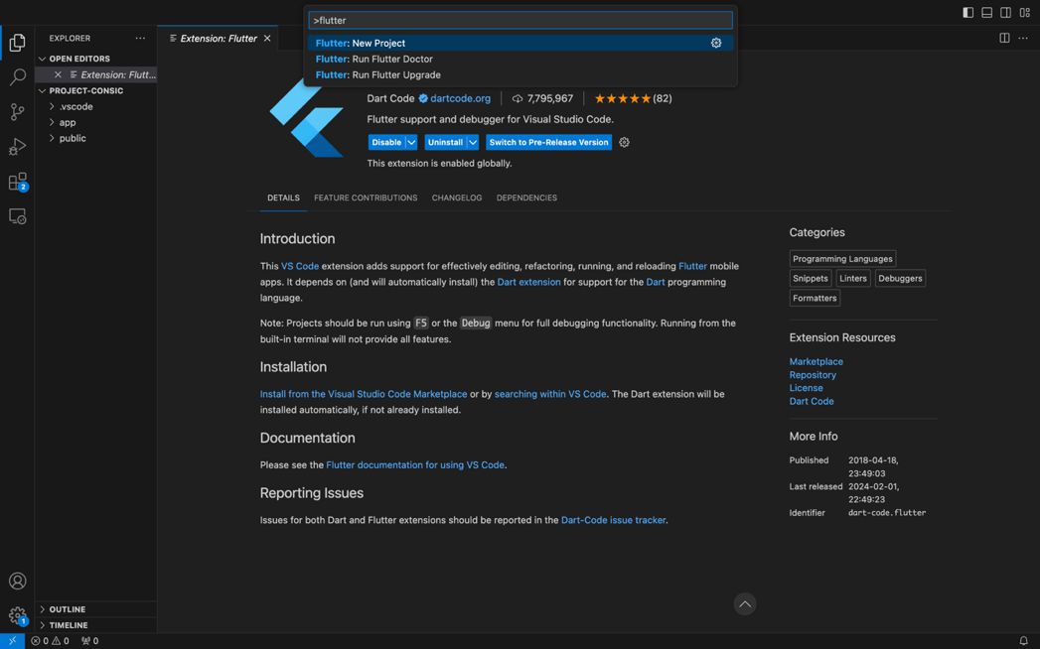

1. Install Flutter SDK

|  |
| --- |
| Buka VSCode -> Command+Shift+P -> Ketik Flutter -> Pilih Flutter: New Project |

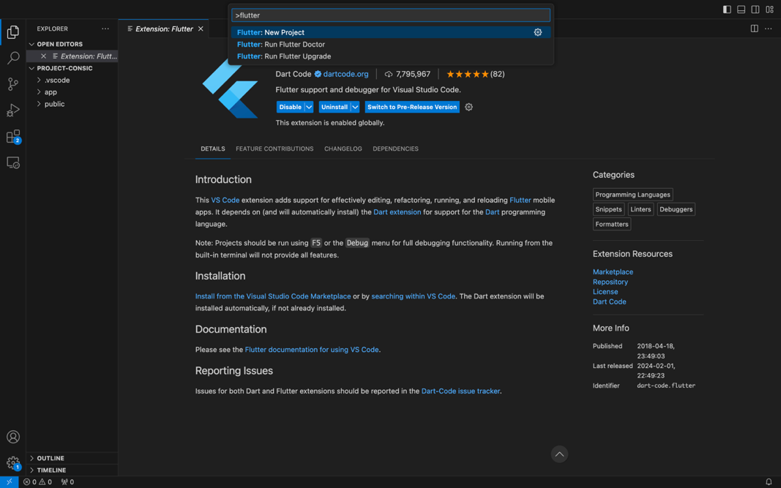

1. Pilih Download SDK

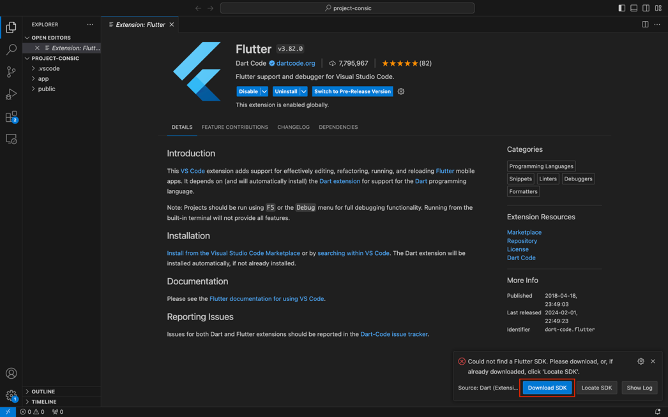

1. Pilih tempat untuk menyimpan file SDK

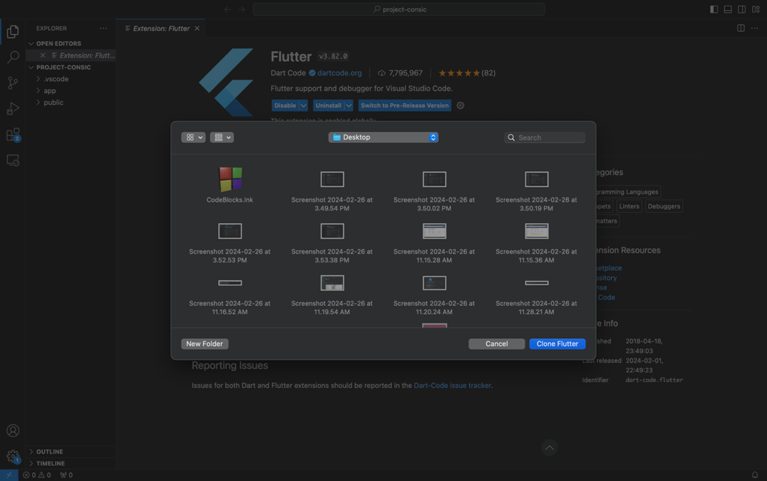

1. Downloading dan Initializing proses

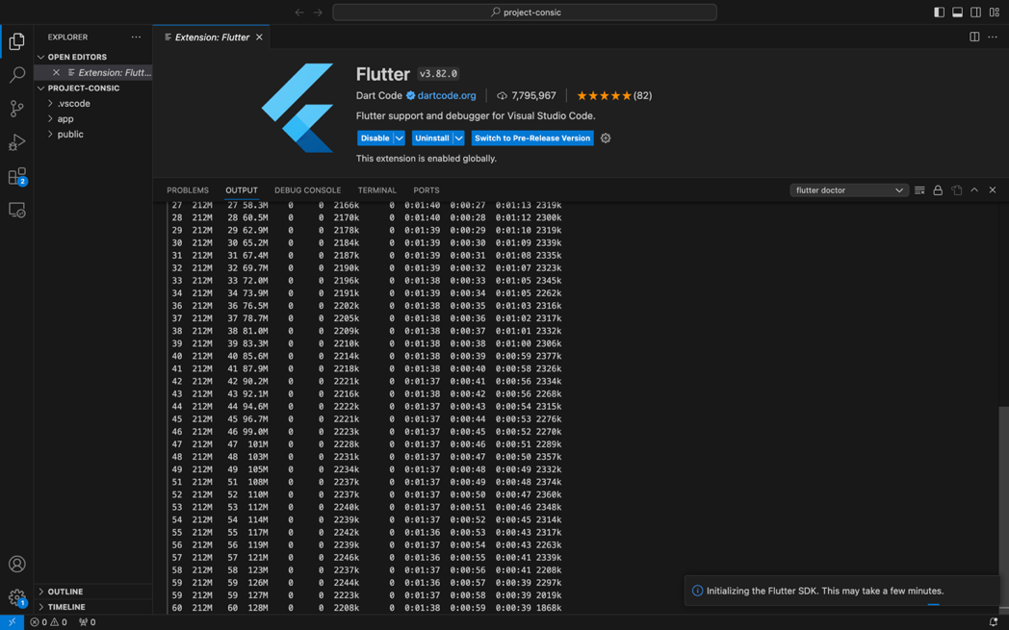

1. Mengaktifkan Flutter pada seluruh terminal

|  |
| --- |
| sudo nano ~/.zshrc  ---  export PATH="$PATH:/Users/Adel/Desktop/flutter/bin"  ---  echo $ PATH |



1. **Validasi Komponen Flutter**

|  |
| --- |
| $ flutter doctor |

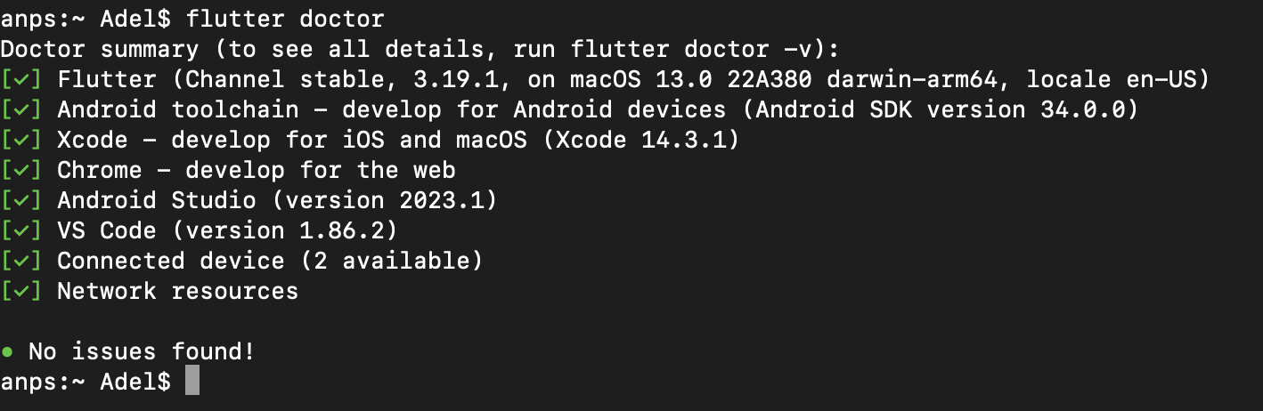

1. **Membuat Aplikasi Flutter**
2. **Membuat proyek Flutter**

Buka Visual Studio Code dan buka palet perintah (Shift+Cmd+P). Ketik "flutter new". Pilih perintah Flutter: New Project.

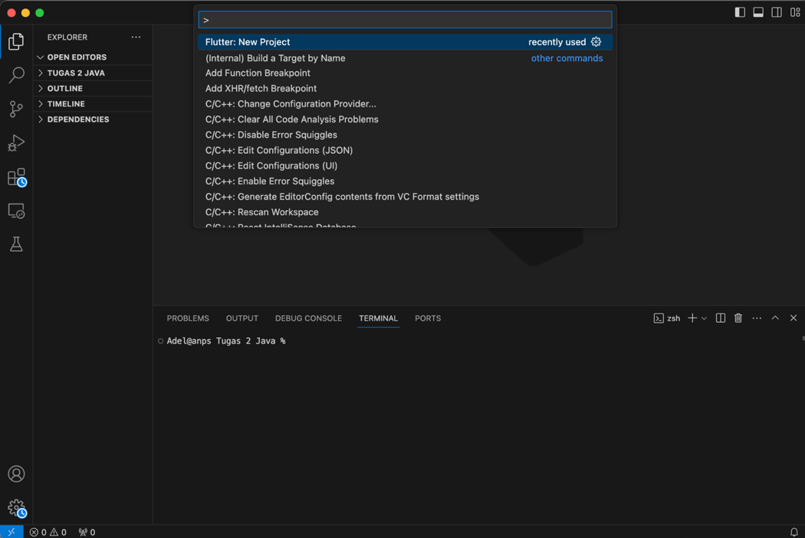

Berikutnya, pilih Application lalu folder tempat project akan dibuat. Beri nama prak_pbm

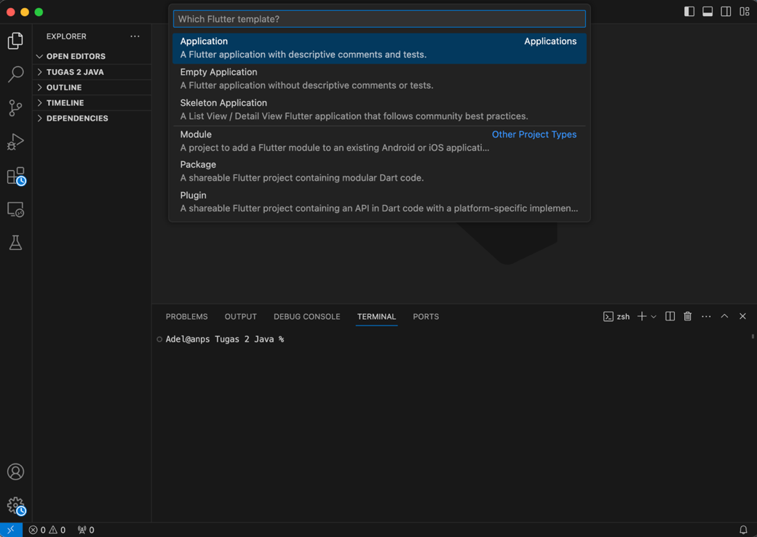

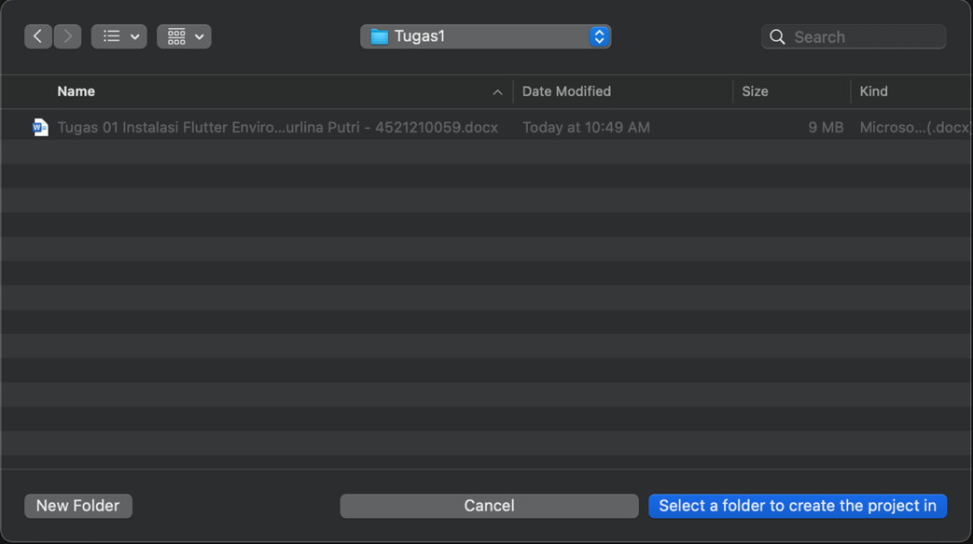

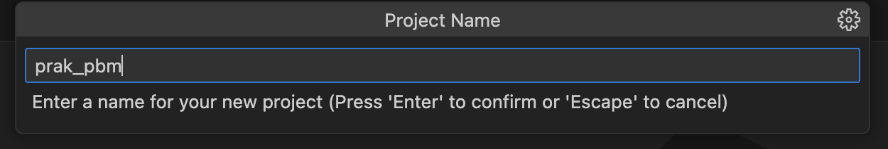

Buka file pubspec.yaml. copy paste :

|  |
| --- |
| name: prak_pbm description: A new Flutter project.  publish_to: 'none' # Remove this line if you wish to publish to pub.dev  version: 0.0.1+1  environment:   sdk: '>=2.19.4 <4.0.0'  dependencies:   flutter:     sdk: flutter    english_words: ^4.0.0   provider: ^6.0.0  dev_dependencies:   flutter_test:     sdk: flutter    flutter_lints: ^2.0.0  flutter:   uses-material-design: true |

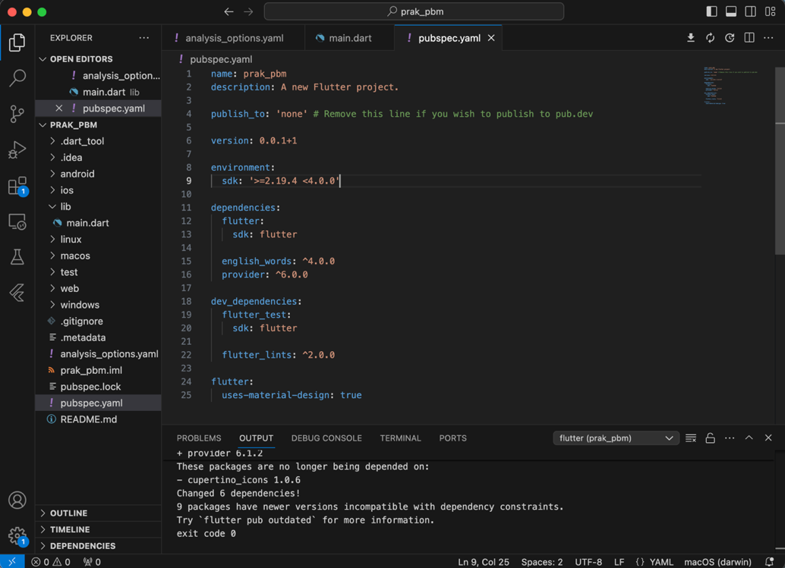

Buka file analysis_options.yaml. copy paste :

|  |
| --- |
| include: package:flutter_lints/flutter.yaml  linter:   rules:     prefer_const_constructors: false     prefer_final_fields: false     use_key_in_widget_constructors: false     prefer_const_literals_to_create_immutables: false     prefer_const_constructors_in_immutables: false     avoid_print: false |

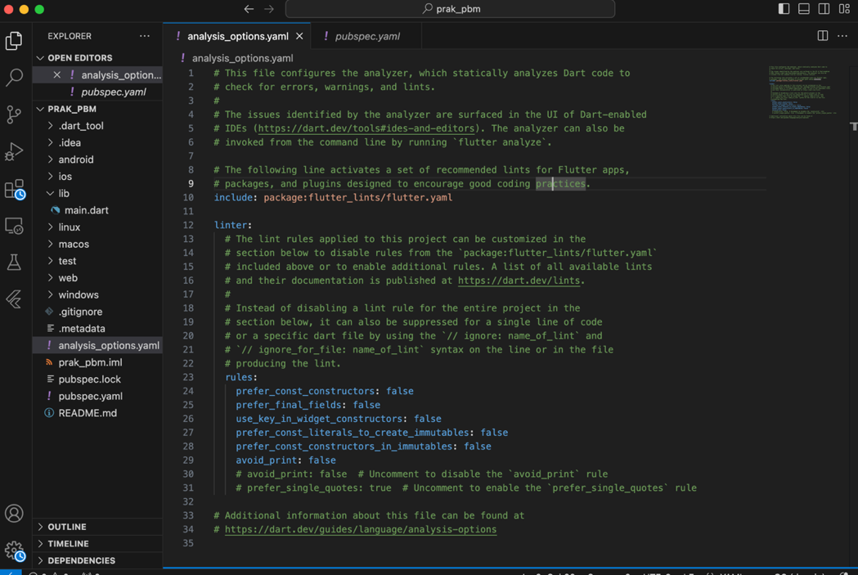

Terakhir buka main.dart pada direktori lib/. copy paste :

|  |
| --- |
| import 'package:english_words/english_words.dart'; import 'package:flutter/material.dart'; import 'package:provider/provider.dart';  void main() {   runApp(MyApp()); }  class MyApp extends StatelessWidget {   const MyApp({super.key});    @override   Widget build(BuildContext context) {     return ChangeNotifierProvider(       create: (context) => MyAppState(),       child: MaterialApp(         title: 'Namer App',         theme: ThemeData(           useMaterial3: true,           colorScheme: ColorScheme.fromSeed(seedColor: Colors.deepOrange),         ),         home: MyHomePage(),       ),     );   } }  class MyAppState extends ChangeNotifier {   var current = WordPair.random(); }  class MyHomePage extends StatelessWidget {   @override   Widget build(BuildContext context) {     var appState = context.watch<MyAppState>();      return Scaffold(       body: Column(         children: [           Text('A random idea:'),           Text(appState.current.asLowerCase),         ],       ),     );   } } |

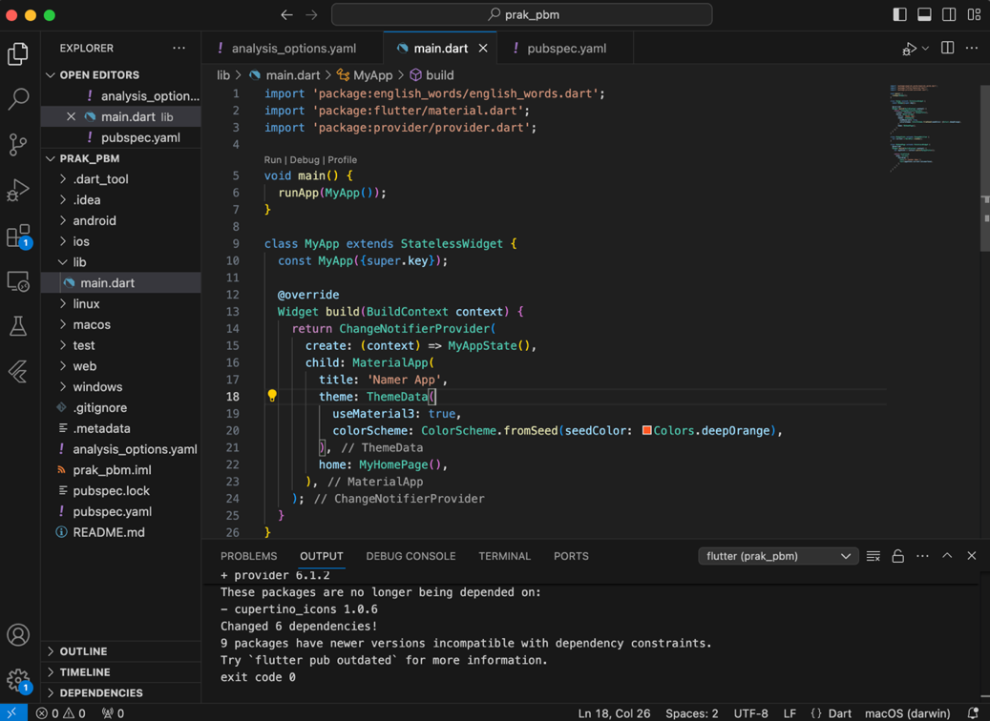

1. **Menambahkan Tombol**
2. **Meluncurkan Aplikasi**

Pertama, buka lib/main.dart dan pastikan Anda memilih perangkat target. Di bagian pojok kanan bawah VS Code. Dan Klik tombol Play diatas kanan untuk Start Debugging.

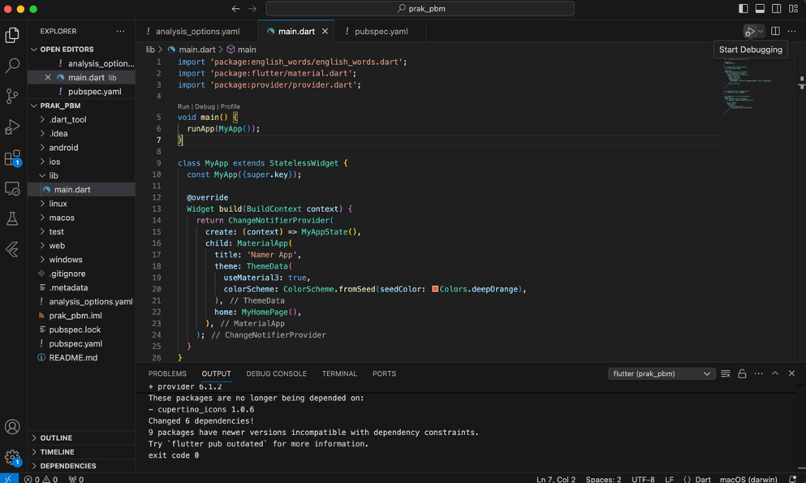

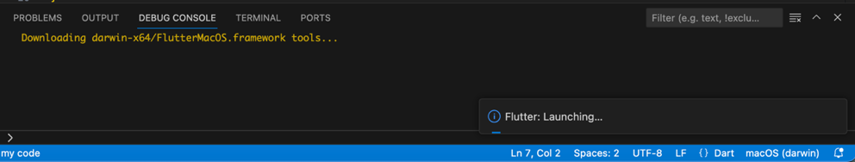

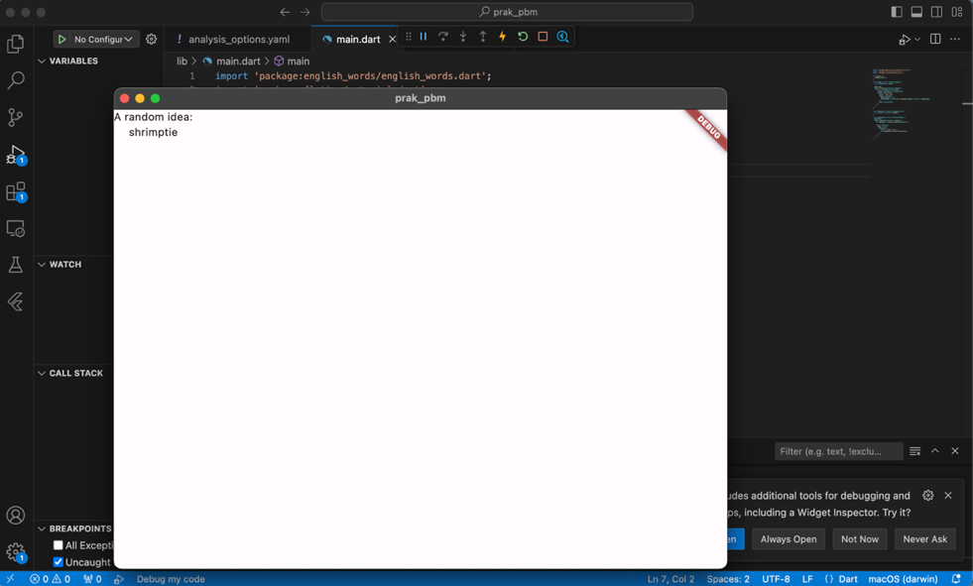

1. **Hot Reload Pertama**

Di bagian bawah lib/main.dart, tambahkan sesuatu pada string di objek Text pertama, dan simpan file tersebut.

|  |
| --- |
| // ...      return Scaffold(       body: Column(         children: [           Text(Adelia Nurlina Putri:'),  // ← Example change.           Text(appState.current.asLowerCase),         ],       ),     );  // ... |

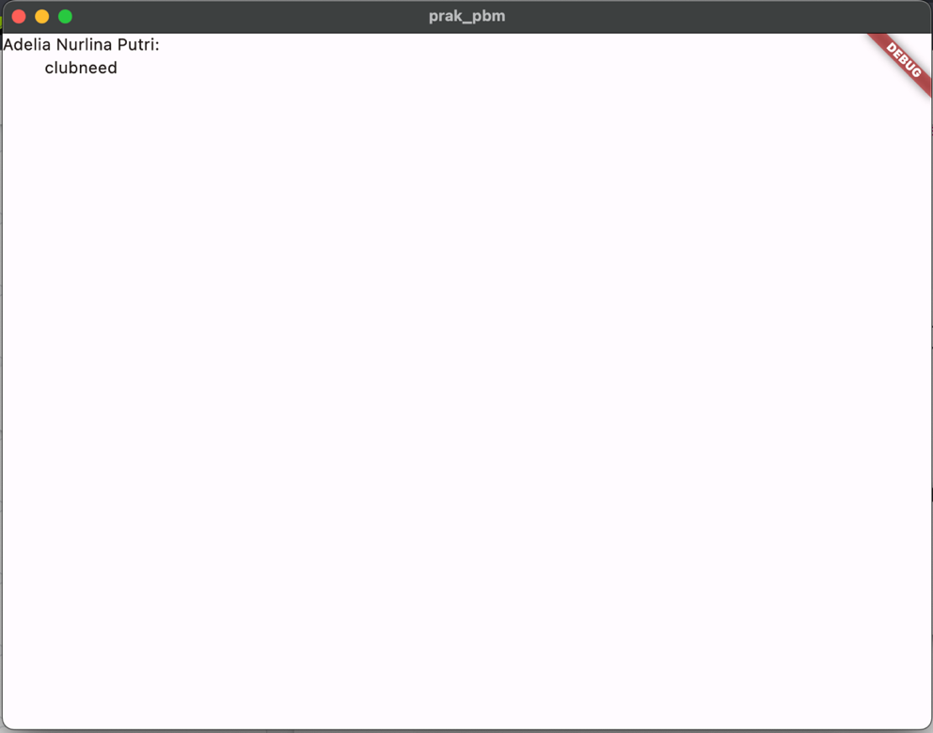

1. **Menambahkan Tombol**

Berikutnya, tambahkan tombol di bagian bawah Column, tepat di bawah instance Text kedua.

|  |
| --- |
| // ...      return Scaffold(       body: Column(         children: [           Text('A random AWESOME idea:'),           Text(appState.current.asLowerCase),            // ↓ Add this.           ElevatedButton(             onPressed: () {               print('button pressed!');             },             child: Text('Next'),           ),          ],       ),     );  // ... |

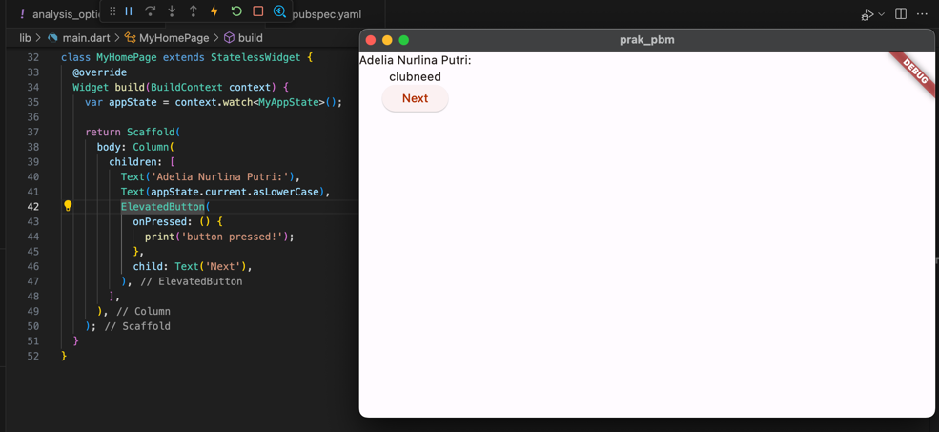

1. **Memperindah Tampilan Aplikasi**
2. **Mengekstrak widget**

Tulis ulang widget MyHomePage sebagai berikut:

|  |
| --- |
| // ...  class MyHomePage extends StatelessWidget {   @override   Widget build(BuildContext context) {     var appState = context.watch<MyAppState>();     var pair = appState.current;                 // ← Add this.      return Scaffold(       body: Column(         children: [           Text('A random AWESOME idea:'),           Text(pair.asLowerCase),                // ← Change to this.           ElevatedButton(             onPressed: () {               appState.getNext();             },             child: Text('Next'),           ),         ],       ),     );   } }  // ... |

Panggil menu Refactor. Pada VS Code pindahkan kursor Anda ke potongan kode yang ingin di faktorkan ulang (dalam hal ini, Text), lalu tekan Cmd+.

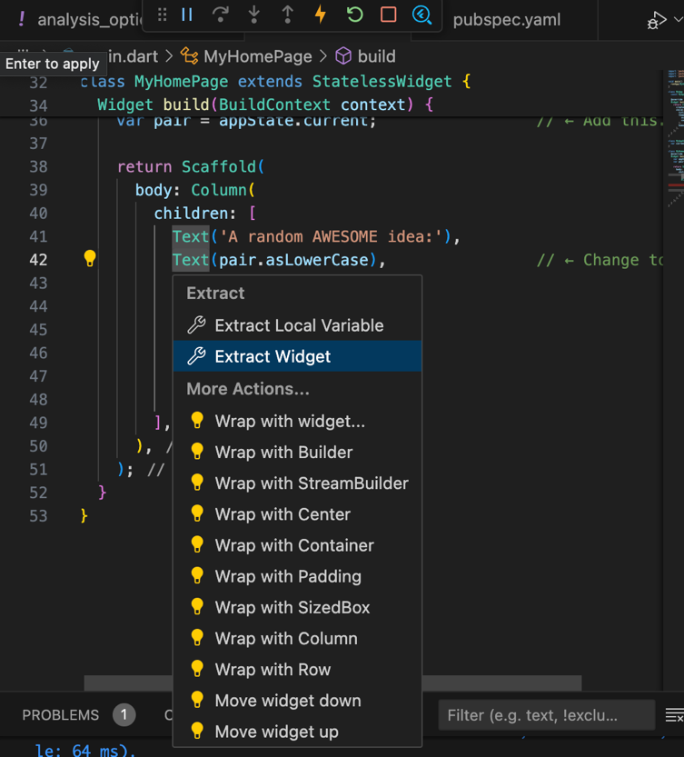

Pada menu Refactor, pilih Extract Widget. Tetapkan nama, seperti BigCard, lalu klik Enter

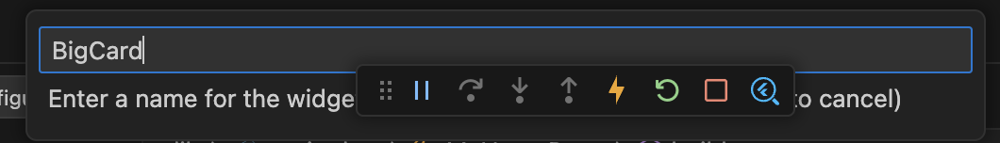

Tindakan ini secara otomatis membuat class baru, BigCard, di akhir file saat ini. Class tersebut akan terlihat seperti berikut:

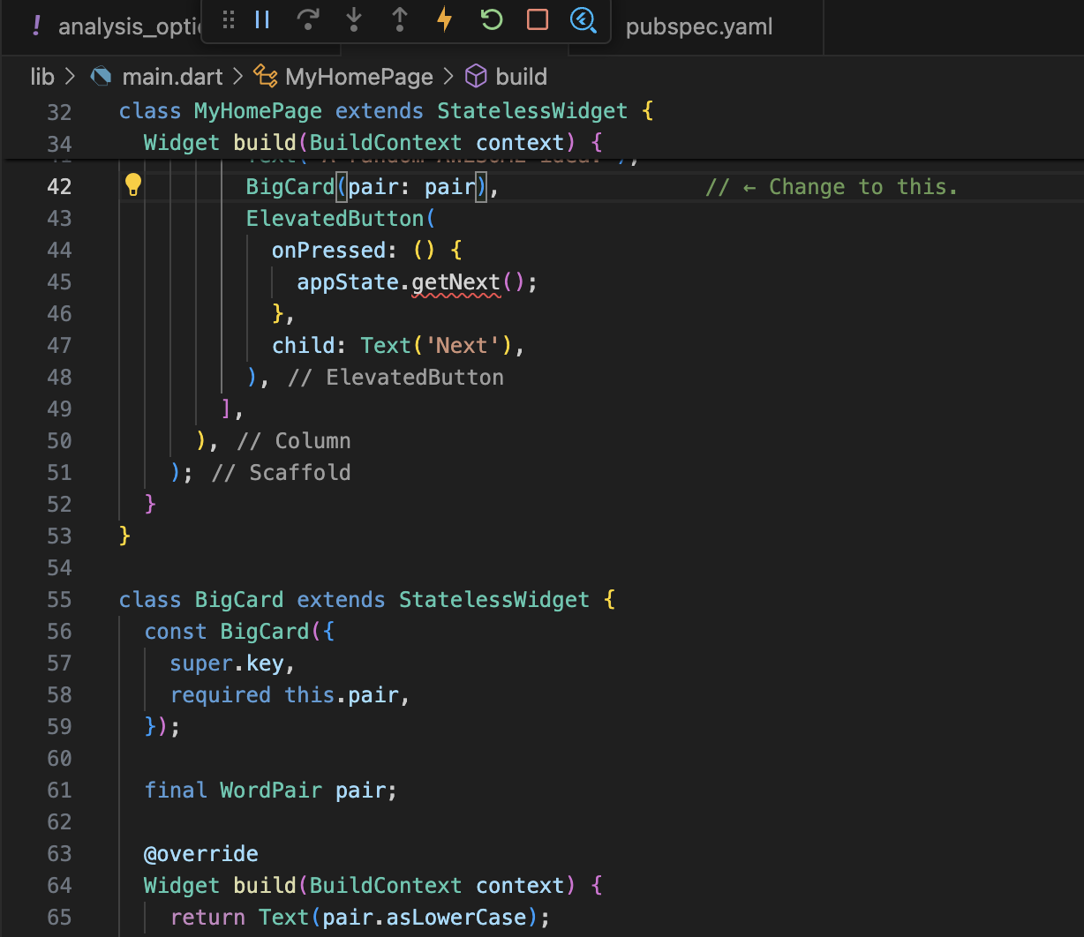

1. **Menambahkan Kartu**

Temukan class BigCard dan metode build() yang berada di dalamnya. Sama seperti sebelumnya, panggil menu Refactor pada widget Text. pilih Wrap with Padding.

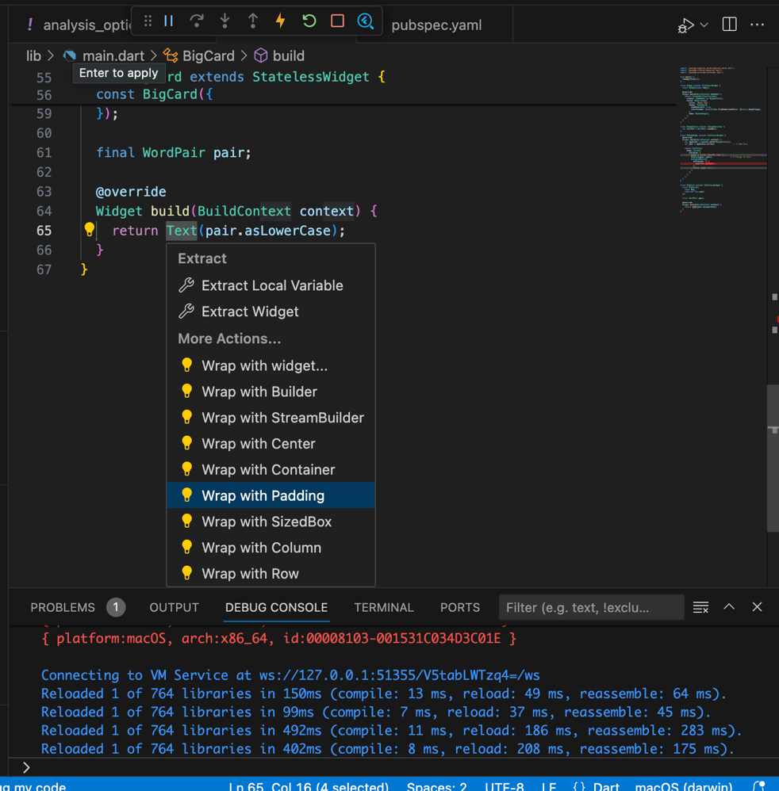

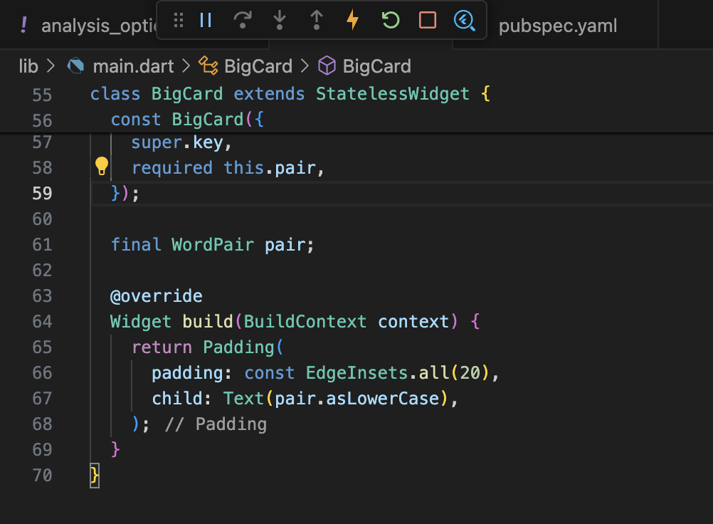

Tempatkan kursor pada widget Padding, buka menu Refactor, lalu pilih Wrap with widget....

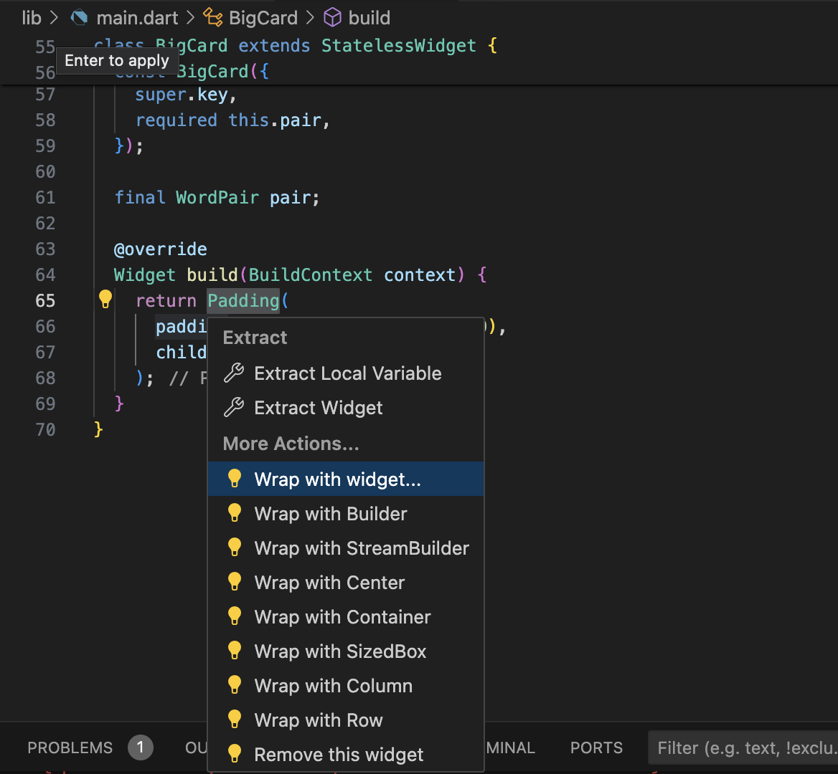

Ubah Padding menjadi Card

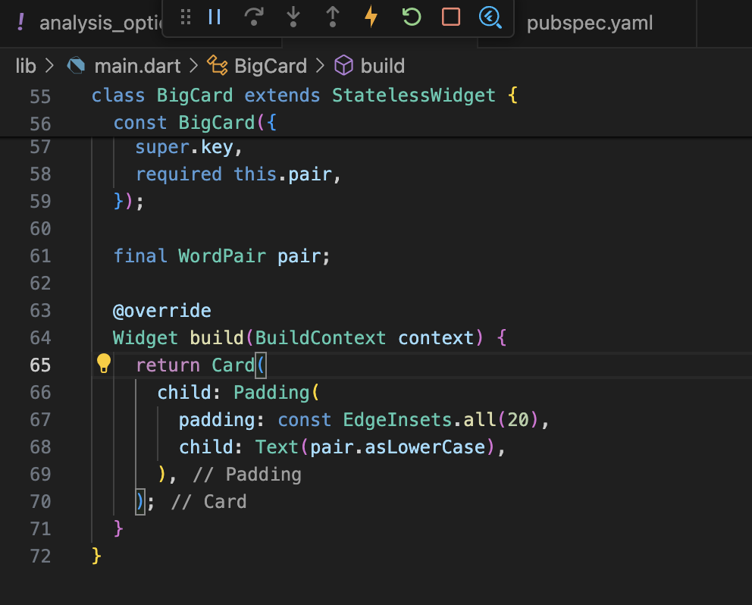

Hasil :

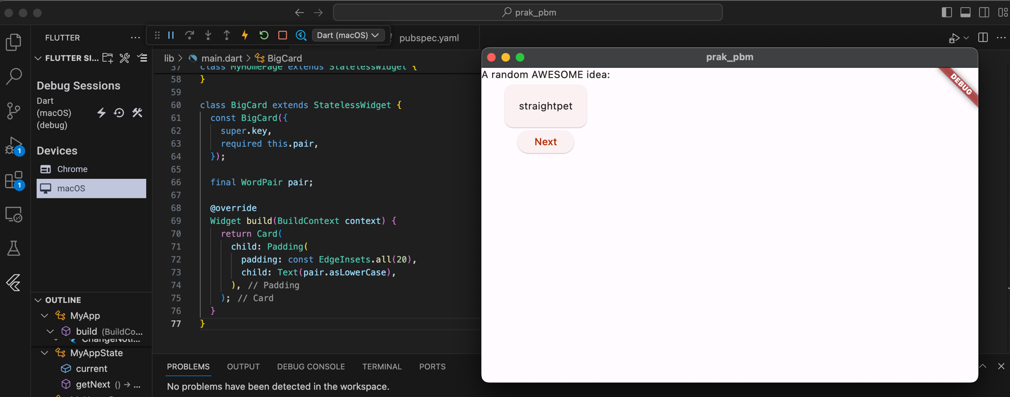

1. **Tema dan Gaya**

Buat perubahan berikut untuk metode build() BigCard

|  |
| --- |
| // ...    @override   Widget build(BuildContext context) {     final theme = Theme.of(context);       // ← Add this.      return Card(       color: theme.colorScheme.primary,    // ← And also this.       child: Padding(         padding: const EdgeInsets.all(20),         child: Text(pair.asLowerCase),       ),     );   }  // ... |

Hasil :

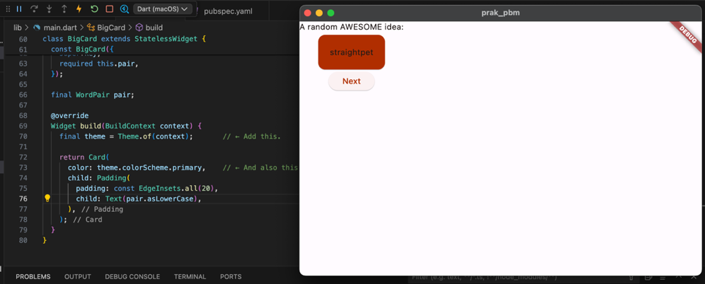

1. **TextTheme**

Perbaiki tampilan card dengan kode berikut :

|  |
| --- |
| // ...    @override   Widget build(BuildContext context) {     final theme = Theme.of(context);     // ↓ Add this.     final style = theme.textTheme.displayMedium!.copyWith(       color: theme.colorScheme.onPrimary,     );      return Card(       color: theme.colorScheme.primary,       child: Padding(         padding: const EdgeInsets.all(20),         // ↓ Change this line.         child: Text(pair.asLowerCase, style: style),       ),     );   }  // ... |

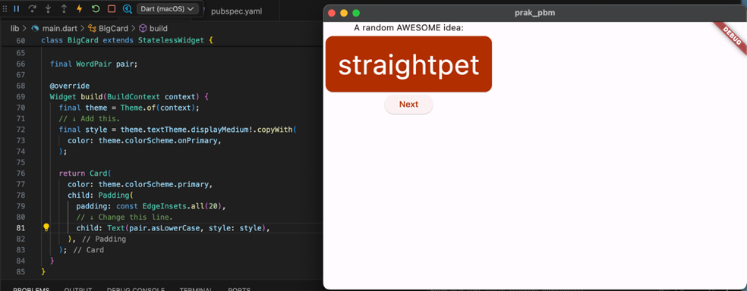

1. **Meningkatkan Aksesibilitas**

Gunakan properti semanticsLabel Text untuk mengganti konten visual widget teks dengan konten semantik yang lebih sesuai untuk pembaca layar:

|  |
| --- |
| // ...    @override   Widget build(BuildContext context) {     final theme = Theme.of(context);     final style = theme.textTheme.displayMedium!.copyWith(       color: theme.colorScheme.onPrimary,     );      return Card(       color: theme.colorScheme.primary,       child: Padding(         padding: const EdgeInsets.all(20),          // ↓ Make the following change.         child: Text(           pair.asLowerCase,           style: style,           semanticsLabel: "${pair.first} ${pair.second}",         ),       ),     );   }  // ... |

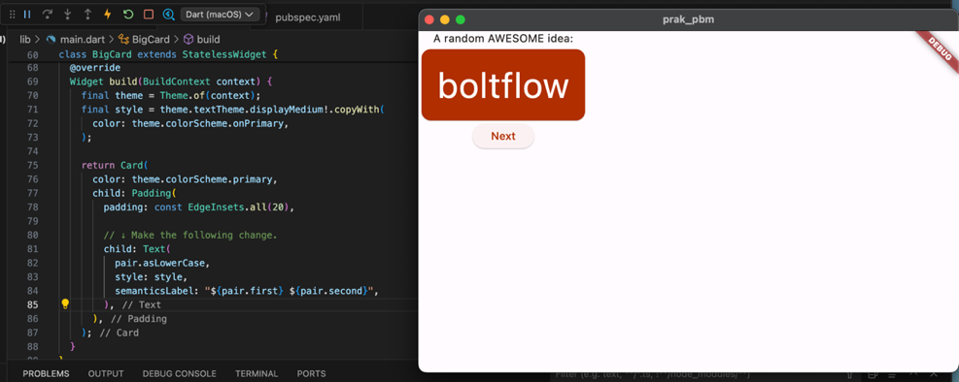

1. **Menempatkan UI di tengah**

Buka metode build() MyHomePage, dan buat perubahan berikut:

|  |
| --- |
| // ...  class MyHomePage extends StatelessWidget {   @override   Widget build(BuildContext context) {     var appState = context.watch<MyAppState>();     var pair = appState.current;      return Scaffold(       body: Column(         mainAxisAlignment: MainAxisAlignment.center,  // ← Add this.         children: [           Text('A random AWESOME idea:'),           BigCard(pair: pair),           ElevatedButton(             onPressed: () {               appState.getNext();             },             child: Text('Next'),           ),         ],       ),     );   } }  // ... |

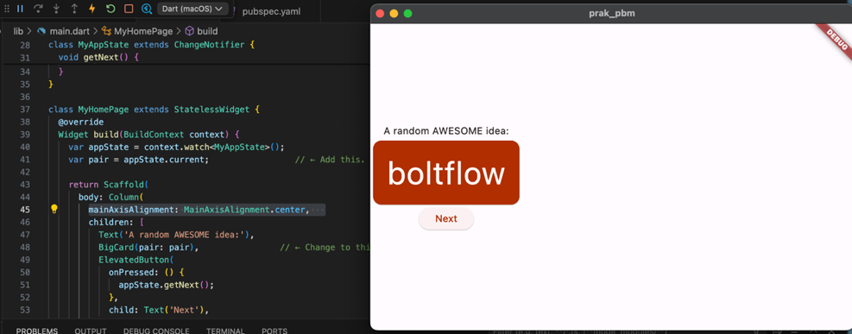

Letakkan kursor Anda di Column, buka menu Refactor (dengan Ctrl+. atau Cmd+.), lalu pilih Wrap with Center.

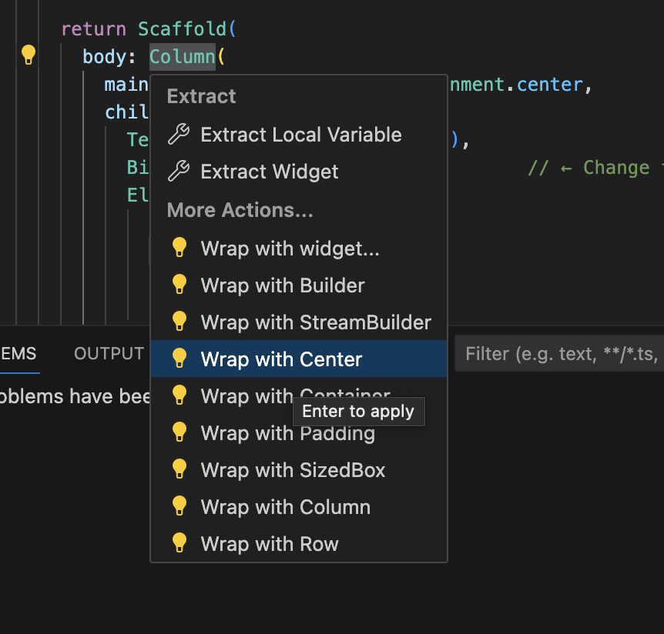

Hasil :

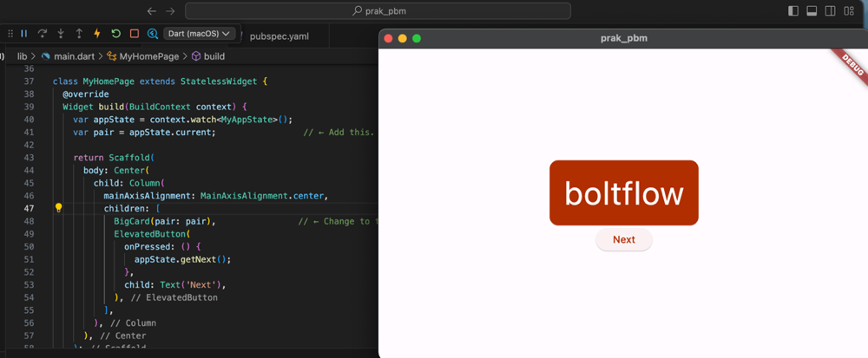

1. **Menambahkan Fungsi**
2. **Menambahkan Logika Bisnis**

Scroll ke MyAppState dan tambahkan kode berikut:

|  |
| --- |
| // ...  class MyAppState extends ChangeNotifier {   var current = WordPair.random();    void getNext() {     current = WordPair.random();     notifyListeners();   }    // ↓ Add the code below.   var favorites = <WordPair>[];    void toggleFavorite() {     if (favorites.contains(current)) {       favorites.remove(current);     } else {       favorites.add(current);     }     notifyListeners();   } }  // ... |

1. **Menambahkan Tombol**

Meletakkan tombol ‘Like' di sebelah kiri tombol ‘Next' memerlukan Row. Pertama, gabungkan tombol yang ada pada Row. Buka metode build() MyHomePage, letakkan kursor pada ElevatedButton, buka menu Refactor dengan Ctrl+. atau Cmd+., lalu pilih Wrap with Row.

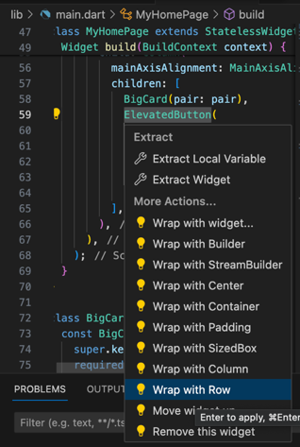

Buat perubahan berikut:

|  |
| --- |
| // ...  class MyHomePage extends StatelessWidget {   @override   Widget build(BuildContext context) {     var appState = context.watch<MyAppState>();     var pair = appState.current;      return Scaffold(       body: Center(         child: Column(           mainAxisAlignment: MainAxisAlignment.center,           children: [             BigCard(pair: pair),             SizedBox(height: 10),             Row(               mainAxisSize: MainAxisSize.min,   // ← Add this.               children: [                 ElevatedButton(                   onPressed: () {                     appState.getNext();                   },                   child: Text('Next'),                 ),               ],             ),           ],         ),       ),     );   } }  // ... |

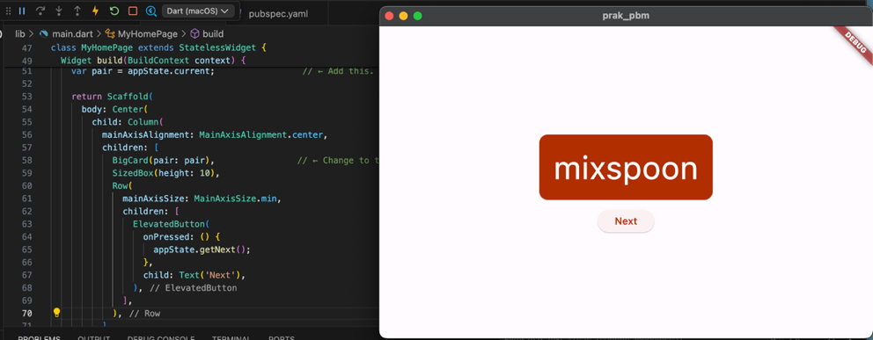

Menambahkan tombol untuk myHomePage menggunakan konstruktor ElevatedButton.icon() untuk membuat tombol dengan ikon. Di bagian atas metode build, pilih ikon yang sesuai tergantung pada apakah pasangan kata saat ini sudah berada di favorit atau tidak.

|  |
| --- |
| // ...  class MyHomePage extends StatelessWidget {   @override   Widget build(BuildContext context) {     var appState = context.watch<MyAppState>();     var pair = appState.current;      // ↓ Add this.     IconData icon;     if (appState.favorites.contains(pair)) {       icon = Icons.favorite;     } else {       icon = Icons.favorite_border;     }      return Scaffold(       body: Center(         child: Column(           mainAxisAlignment: MainAxisAlignment.center,           children: [             BigCard(pair: pair),             SizedBox(height: 10),             Row(               mainAxisSize: MainAxisSize.min,               children: [                  // ↓ And this.                 ElevatedButton.icon(                   onPressed: () {                     appState.toggleFavorite();                   },                   icon: Icon(icon),                   label: Text('Like'),                 ),                 SizedBox(width: 10),                  ElevatedButton(                   onPressed: () {                     appState.getNext();                   },                   child: Text('Next'),                 ),               ],             ),           ],         ),       ),     );   } }  // ... |

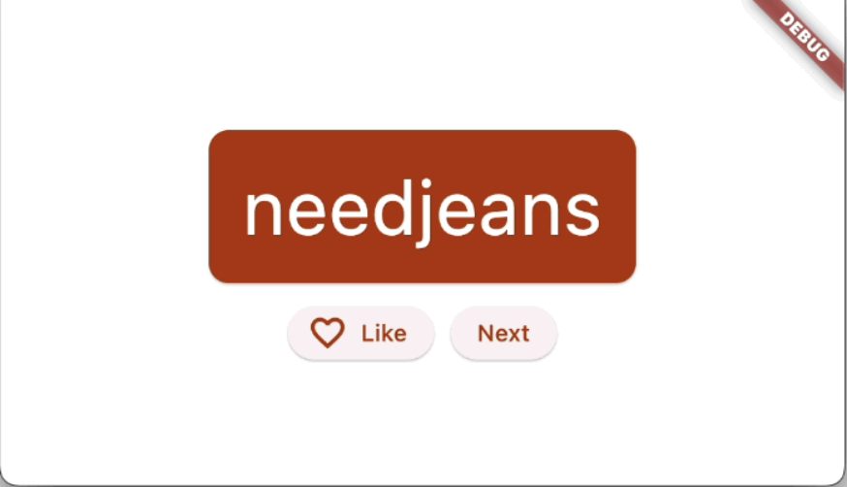

1. **Menambahkan Kolom Samping**
2. **Pisahkan MyHomePage menjadi 2 widget terpisah**

Pilih keseluruhan MyHomePage, hapus, dan gantikan dengan kode berikut:

|  |
| --- |
| // ...  class MyHomePage extends StatelessWidget {   @override   Widget build(BuildContext context) {     return Scaffold(       body: Row(         children: [           SafeArea(             child: NavigationRail(               extended: false,               destinations: [                 NavigationRailDestination(                   icon: Icon(Icons.home),                   label: Text('Home'),                 ),                 NavigationRailDestination(                   icon: Icon(Icons.favorite),                   label: Text('Favorites'),                 ),               ],               selectedIndex: 0,               onDestinationSelected: (value) {                 print('selected: $value');               },             ),           ),           Expanded(             child: Container(               color: Theme.of(context).colorScheme.primaryContainer,               child: GeneratorPage(),             ),           ),         ],       ),     );   } }  class GeneratorPage extends StatelessWidget {   @override   Widget build(BuildContext context) {     var appState = context.watch<MyAppState>();     var pair = appState.current;      IconData icon;     if (appState.favorites.contains(pair)) {       icon = Icons.favorite;     } else {       icon = Icons.favorite_border;     }      return Center(       child: Column(         mainAxisAlignment: MainAxisAlignment.center,         children: [           BigCard(pair: pair),           SizedBox(height: 10),           Row(             mainAxisSize: MainAxisSize.min,             children: [               ElevatedButton.icon(                 onPressed: () {                   appState.toggleFavorite();                 },                 icon: Icon(icon),                 label: Text('Like'),               ),               SizedBox(width: 10),               ElevatedButton(                 onPressed: () {                   appState.getNext();                 },                 child: Text('Next'),               ),             ],           ),         ],       ),     );   } }  // ... |

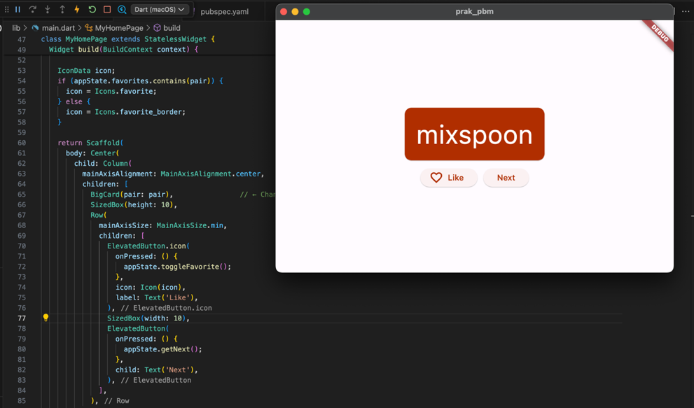

1. **Widget stateless versus stateful**

Pertama, konversi MyHomePage menjadi widget stateful. Tempatkan kursor Anda di baris pertama MyHomePage (baris yang diawali dengan class MyHomePage...), lalu buka menu Refactor menggunakan Ctrl+. atau Cmd+.. Kemudian, pilih Convert to StatefulWidget.

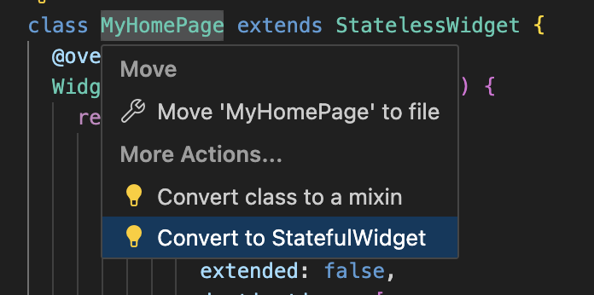

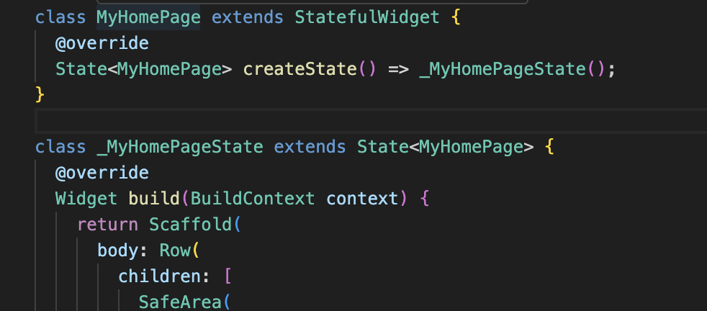

1. **setState**

Widget stateful baru hanya perlu melacak satu variabel: selectedIndex. Buat 3 perubahan berikut untuk _MyHomePageState :

|  |
| --- |
| // ...  class _MyHomePageState extends State<MyHomePage> {    var selectedIndex = 0;     // ← Add this property.    @override   Widget build(BuildContext context) {     return Scaffold(       body: Row(         children: [           SafeArea(             child: NavigationRail(               extended: false,               destinations: [                 NavigationRailDestination(                   icon: Icon(Icons.home),                   label: Text('Home'),                 ),                 NavigationRailDestination(                   icon: Icon(Icons.favorite),                   label: Text('Favorites'),                 ),               ],               selectedIndex: selectedIndex,    // ← Change to this.               onDestinationSelected: (value) {                  // ↓ Replace print with this.                 setState(() {                   selectedIndex = value;                 });                },             ),           ),           Expanded(             child: Container(               color: Theme.of(context).colorScheme.primaryContainer,               child: GeneratorPage(),             ),           ),         ],       ),     );   } }  // ... |

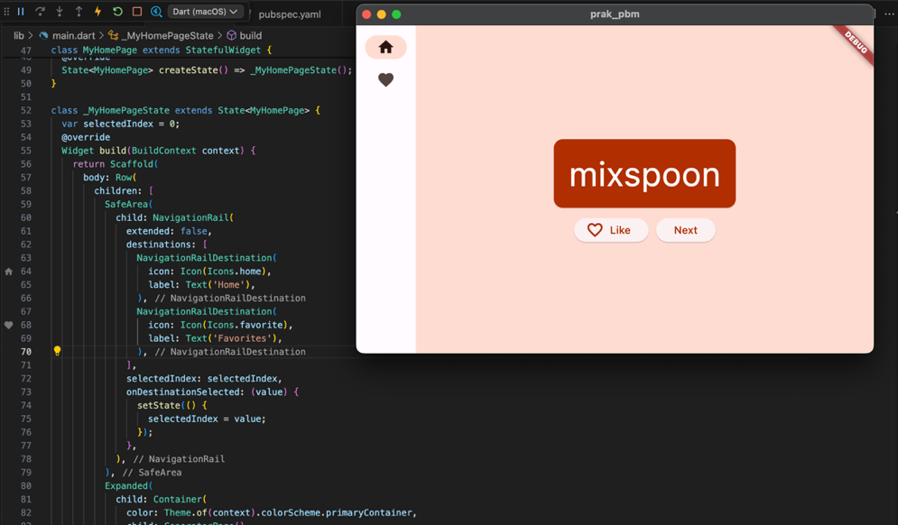

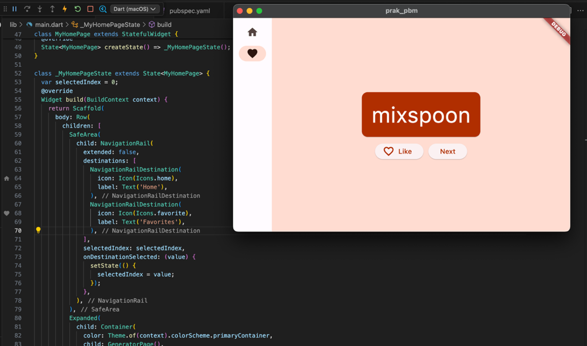

1. **Menggunakan selectedIndex**

Tempatkan kode berikut di bagian atas metode build _MyHomePageState, tepat sebelum return Scaffold:

|  |
| --- |
| // ...  Widget page; switch (selectedIndex) {   case 0:     page = GeneratorPage();     break;   case 1:     page = Placeholder();     break;   default:     throw UnimplementedError('no widget for $selectedIndex'); }  // ... |

Aplikasi sekarang beralih di antara GeneratorPage kita dan placeholder yang akan segera menjadi halaman Favorites.

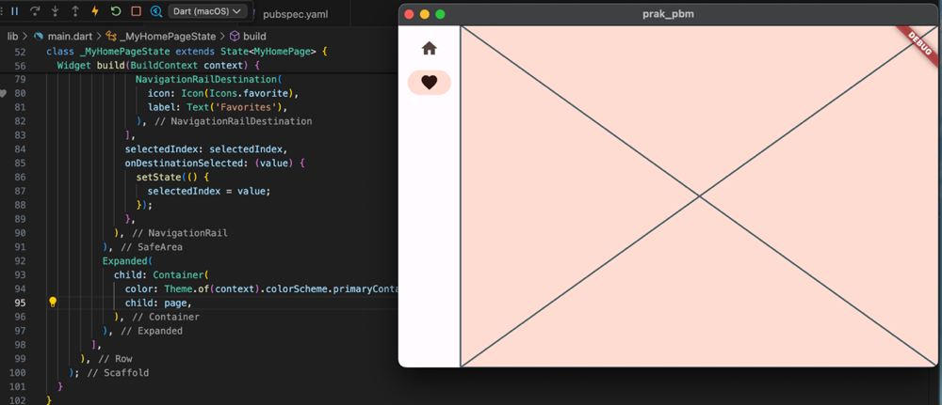

1. **Tingkat respons**

Gunakan menu Refactor Flutter di VS Code untuk membuat perubahan yang diperlukan

* Dalam metode build _MyHomePageState, letakkan kursor Anda pada Scaffold.
* Buka menu Refactor dengan Cmd+. (Mac).
* Pilih Wrap with Builder dan tekan Enter.
* Modifikasi nama Builder yang baru ditambahkan menjadi LayoutBuilder.
* Modifikasi daftar parameter callback dari (context) menjadi (context, constraints).

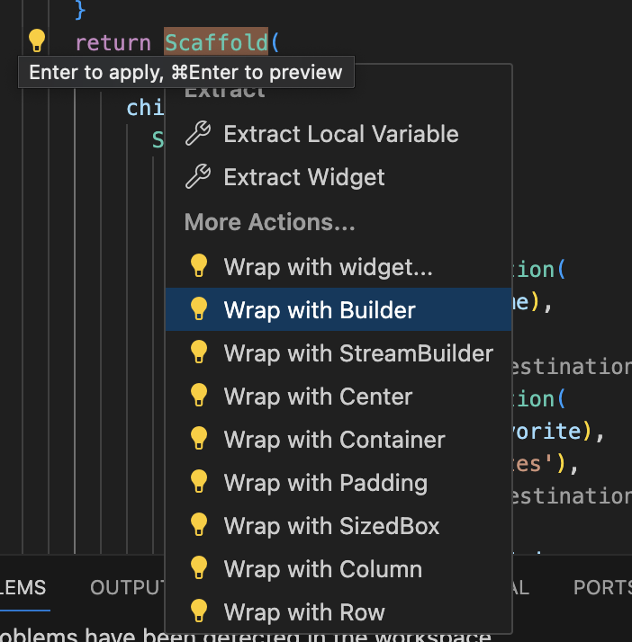

Buat perubahan baris tunggal berikut untuk metode build _MyHomePageState:

|  |
| --- |
| // ...  class _MyHomePageState extends State<MyHomePage> {   var selectedIndex = 0;    @override   Widget build(BuildContext context) {     Widget page;     switch (selectedIndex) {       case 0:         page = GeneratorPage();         break;       case 1:         page = Placeholder();         break;       default:         throw UnimplementedError('no widget for $selectedIndex');     }      return LayoutBuilder(builder: (context, constraints) {       return Scaffold(         body: Row(           children: [             SafeArea(               child: NavigationRail(                 extended: constraints.maxWidth >= 600,  // ← Here.                 destinations: [                   NavigationRailDestination(                     icon: Icon(Icons.home),                     label: Text('Home'),                   ),                   NavigationRailDestination(                     icon: Icon(Icons.favorite),                     label: Text('Favorites'),                   ),                 ],                 selectedIndex: selectedIndex,                 onDestinationSelected: (value) {                   setState(() {                     selectedIndex = value;                   });                 },               ),             ),             Expanded(               child: Container(                 color: Theme.of(context).colorScheme.primaryContainer,                 child: page,               ),             ),           ],         ),       );     });   } }  // ... |

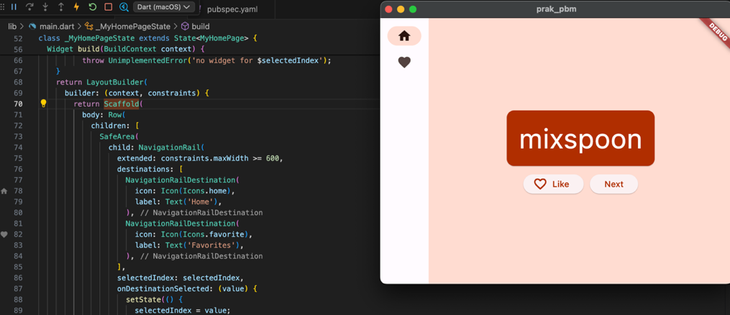

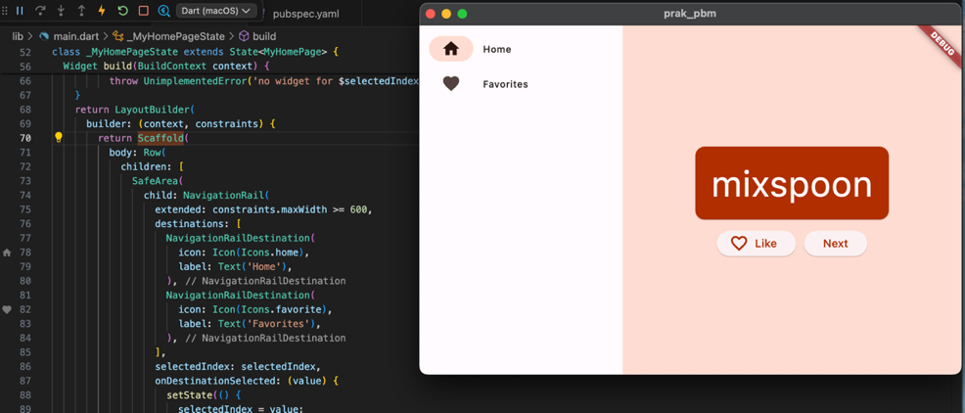

1. **Menambahkan Halaman Baru**

Class FavoritesPage baru :

|  |
| --- |
| // ...  class FavoritesPage extends StatelessWidget {   @override   Widget build(BuildContext context) {     var appState = context.watch<MyAppState>();      if (appState.favorites.isEmpty) {       return Center(         child: Text('No favorites yet.'),       );     }      return ListView(       children: [         Padding(           padding: const EdgeInsets.all(20),           child: Text('You have '               '${appState.favorites.length} favorites:'),         ),         for (var pair in appState.favorites)           ListTile(             leading: Icon(Icons.favorite),             title: Text(pair.asLowerCase),           ),       ],     );   } } |

Mengganti widget Placeholder dengan FavoritesPage :

|  |
| --- |
| Widget build(BuildContext context) {  Widget page;  switch (selectedIndex) {  case 0:  page = GeneratorPage();  break;  case 1:  page = FavoritesPage();  break;  default:  throw UnimplementedError('no widget for $selectedIndex');  } |

Hasil :

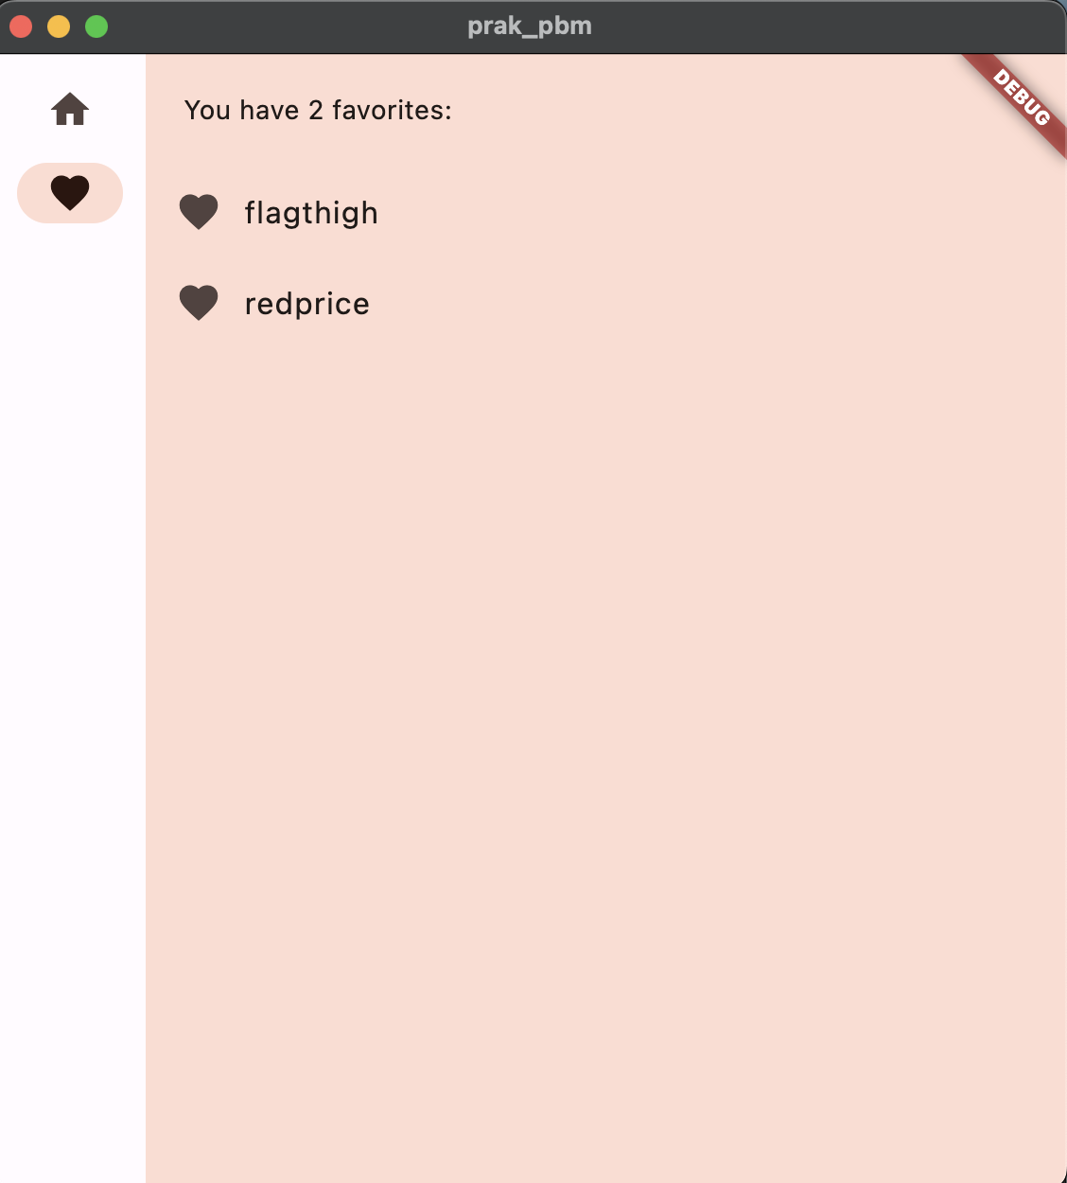

1. **Push Code to GitHub** <https://github.com/adelianurlinap/Prak_PBM.git>
2. Clone Repository yang telah dibuat :

|  |
| --- |
| git clone https://github.com/adelianurlinap/Prak_PBM.git |

1. Add dan commit

|  |
| --- |
| git add .  git commit -m "Tugas1" |

1. Push code

|  |
| --- |
| git push |

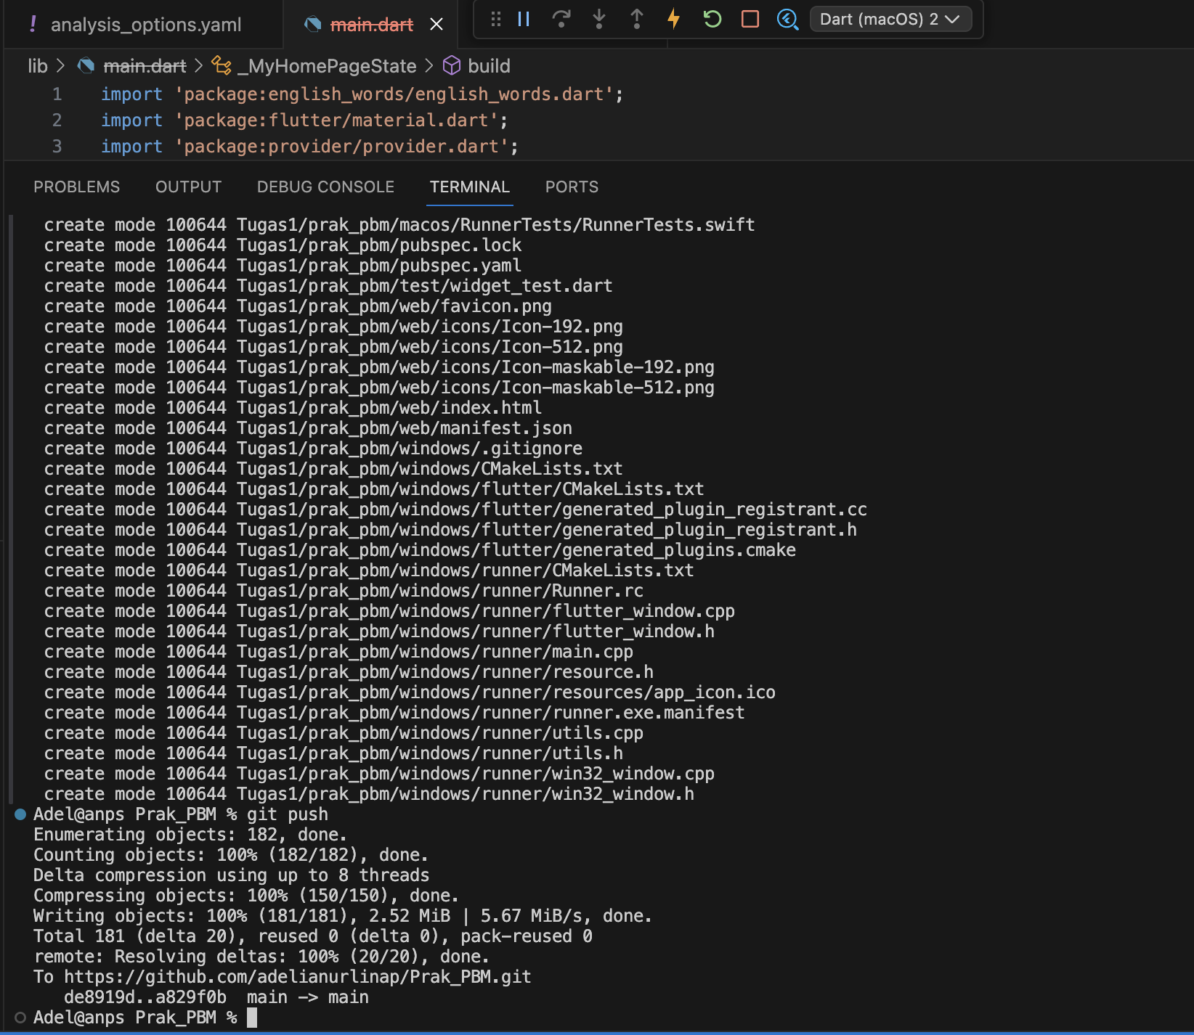

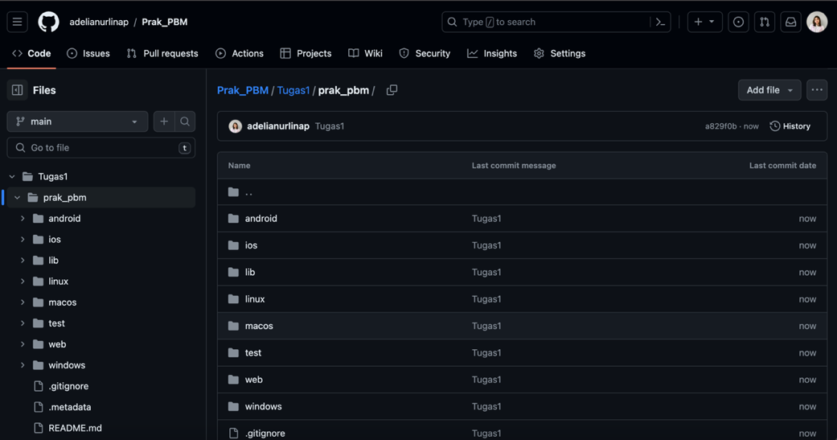

1. **Kesimpulan**

Pada tugas 1 ini, telah dilakukan praktek untuk membuat aplikasi flutter dasar. Aplikasi berbentuk 2 page dengan card random string yang dapat berubah-ubah di like sebagai favorite. Terdapat 2 page yaitu page Home dan Favorite. Diatur juga mengenai responsif dari window page. Terakhir yaitu melakukan push code ke GitHub.

1. **Referensi**

* <https://docs.flutter.dev/get-started/install/macos/mobile-android?tab=virtual>
* <https://marketplace.visualstudio.com/items?itemName=Dart-Code.flutter>
* <https://docs.flutter.dev/get-started/install/macos/mobile-android?tab=virtual>
* <https://docs.flutter.dev/get-started/install/macos/mobile-ios>
* <https://www.codewithhussain.com/flutter-cmdline-tools-component-is-missing>
* <https://codelabs.developers.google.com/codelabs/flutter-codelab-first?hl=id#0>